**UAT server access links For Partner admin Creation and Partnerportal link:**

**Registration :**

[**https://vastu.valucircles.com/orangeretail/#/Register**](https://vastu.valucircles.com/orangeretail/#/Register)

(Basically any new partnerlink has to be replaced in the place of orangeretail) for doing a registration

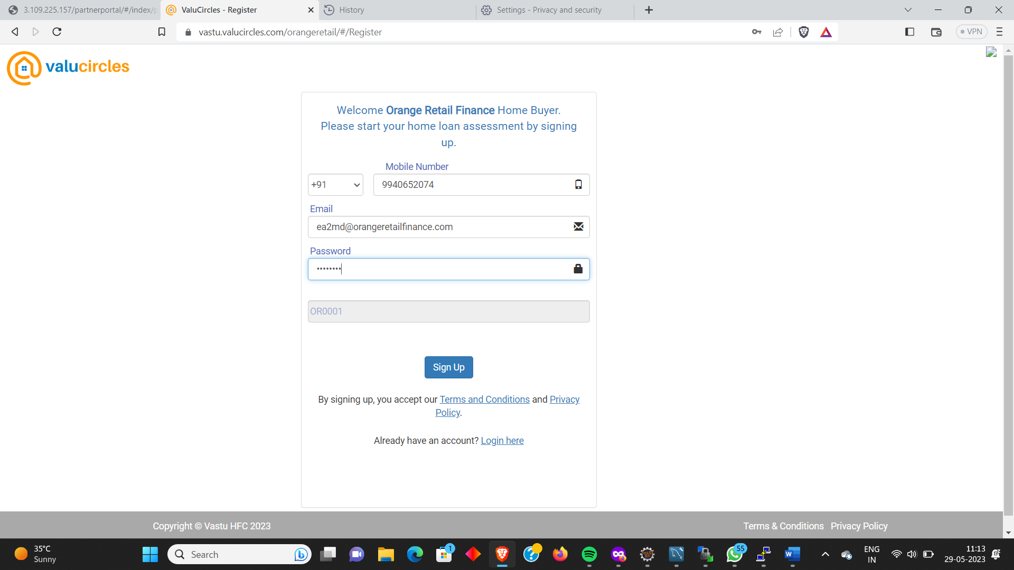

Once the admin user is registered , manually need to change the userTypeId to 3 in user_login table

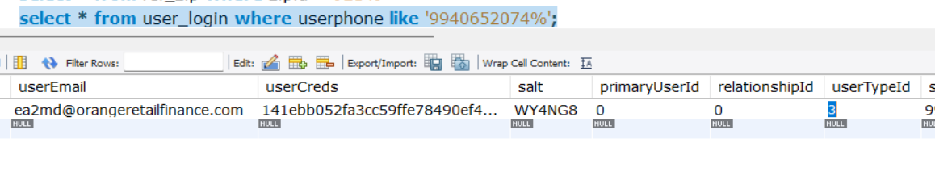

In ref_promo_code, a new entry has to be added

|  |
| --- |
| INSERT INTO `staging`.`ref_promo_code` (`promoCodeId`, `promoCode`, `affiliateType`, `affiliateName`, `affiliateID`) VALUES ('5', 'OR0001', 'Builder', 'Orange Retail Finance', '6012'); |

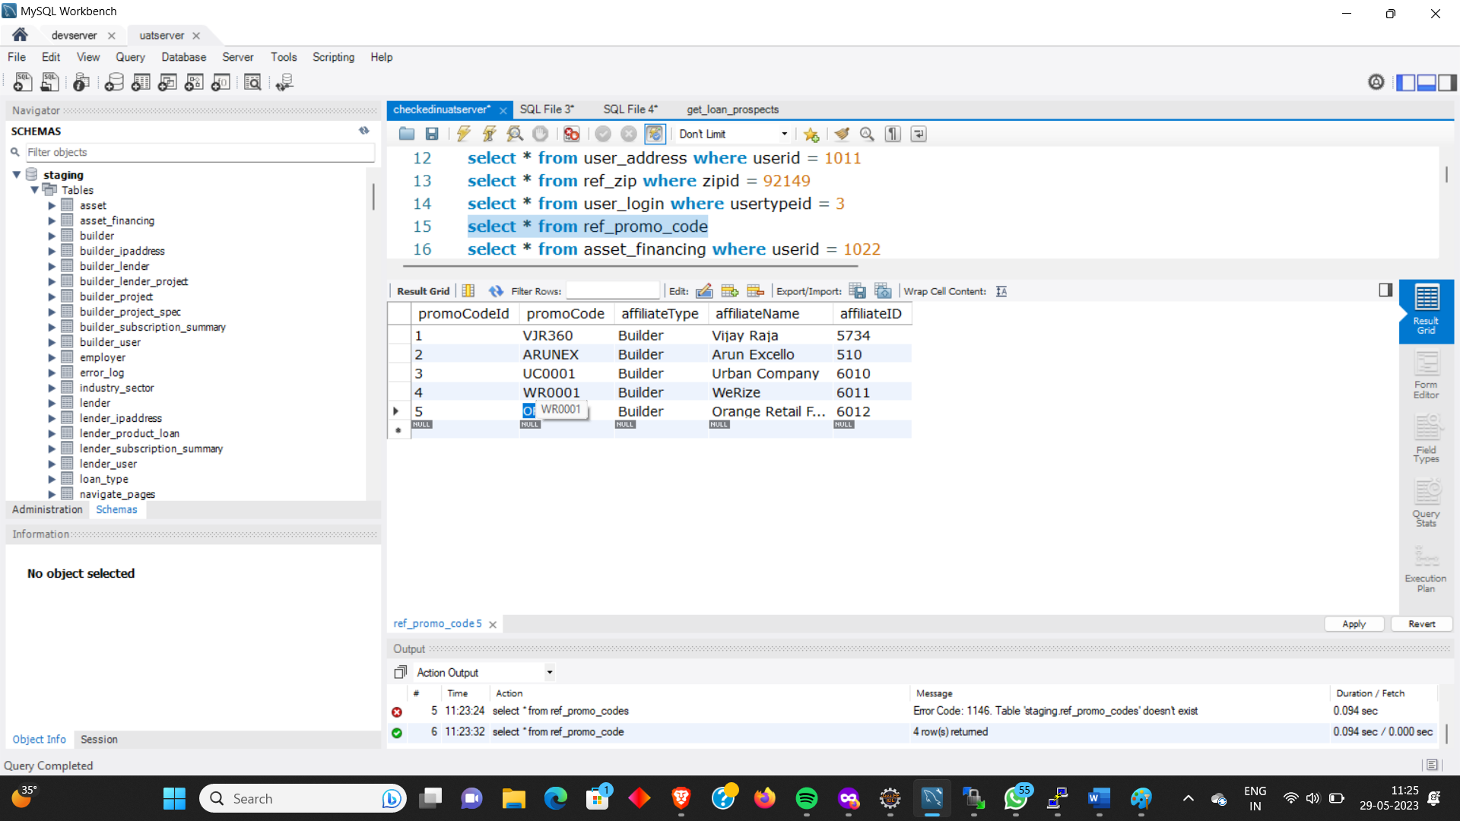

IN builder table, a new entry is added with builderid = 6012

|  |
| --- |
| INSERT INTO `staging`.`builder` (`builderId`, `builderName`, `zipId`, `activeStatus`) VALUES ('6012', 'Orange Retail Finance', '0', '1'); |

Associate the currently created builder with the registered admin email id

|  |
| --- |
| INSERT INTO `staging`.`builder_user` (`builderUserId`, `userId`, `builderId`, `createdOn`, `createdBy`, `updatedOn`, `updatedBy`, `activeStatus`, `refUserTypeId`) VALUES ('5', '1027', '6012', '2023-05-29', 'Priyaraj', '2023-05-29', 'Priyaraj', '1', '3'); |

**PartnerPortal Admin Login :**

[https://vastu.valucircles.com/partnerportal/#/login](https://vastu.valucircles.com/partnerportal/%23/login)

(This is always same for any partners. Depends upon the email id they provide, their corresponding customer leads will be displayed )

For orangeretail : [ea2md@orangeretailfinance.com/Test@123](mailto:ea2md@orangeretailfinance.com/Test@123)

For werize : [mahesh.hegde@werize.com/Test@123](mailto:mahesh.hegde@werize.com/Test@123)

For urbancompany : minshularora@urbancompany.com/Test@123

